SH21789A Abel closed cup Flash point tester
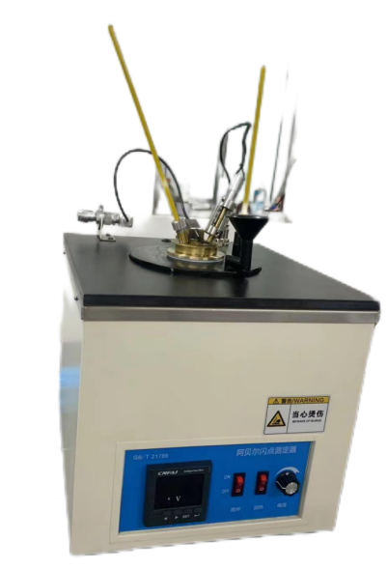
SH21789A Abel closed Flash point tester suitable for the determination of petroleum products and other liquids with flash point between -30 °C ~ 70 °C, precision is only suitable for samples with flash point between -5 °C ~ 66.5 °C, not suitable for water-based coatings. Can be used for flash point determination of aviation (jet) fuels.
SH21789A Abel closed Flash point tester meets the requirements of GB/T 21789, ISO 13736 Test method for determination of flash point of petroleum products and other liquids (Abel closed cup method).

Model | SH21789A
 | Flash point tester (Abel closed cup method)
Manufacturer | Shandong Shengtai Instrument Co., Ltd
Test item | It is suitable for determining petroleum products and other liquids with flash point between -30 °C ~ 70 °C, and the precision is only suitable for samples with flash point between -5 °C ~ 66.5 °C, not suitable for water-based coatings
Meet the standard | GB/T 21789、ISO 13736 Determination of flash point of petroleum products and other liquids (Abel closed cup method)
technical characteristics or parameters | Measuring range：-30～70℃
Features
1. All stainless steel gas pipe
2. High-precision needle valve
3. Standard reagent calibration
4. Optional low temperature circulation bath
Technical parameters
Power supply | AC 220V± 10% 50Hz
Power | 350W
Ignition method | gas ignition
Measuring range | Room temperature to 70℃, or -30 to 70℃ (Optional low-temperature circulating bath)
Stirring speed | 30 r/min
Repetition error | <±1°C
Environmental requirements | temperature 5~40°C;  Humidity≤85%
Packaging abel flash point | size: 560*550*650mm  Weight: 45kg
Abel flash point | size: 480*450*550mm  Weight: 40kg

Packaging and delivery
No. | Name | Unit | Quantity | Remarks
1 | host | Set | 1
2 | Fuse wire | pieces | 1
3 | Test cup | only | 1
4 | Test cup lid | Set of | 1
5 | Thermometer | Piece | 2
6 | Thermometer sleeve | pieces | 2
7 | instructions | copy | 1
8 | Packing list | copy | 1
9 | Warranty card | copy | 1

